**Name :**

**Roll no :**

**Group A Lab Assignment:** 4.2

**Subject :**PSDL

**Title :** Divide 8 bit number by 8 bit number

**Assignment No: 4.2**

**Title :** Embedded C menu driven Program for Dividing 8 bit number by 8 bit number

**Aim:** Write an Embedded C menu driven Program for Dividing 8 bit number by 8 bit number.

**Objective:** To develop and execute embedded C program for division operation for 8 bit number by 8 bit number for PIC18FXXX microcontrollers**.**

**Theory:**

**1). Programming of PIC microcontroller in Embedded C**

PIC18F4550 has a total of 35 I/O (input-output) pins which are distributed among 5 Ports A,B,C,D AND E. Each Port of a **microcontroller** corresponds to three 8-bit registers (TRIS, PORT & LAT) which should be configured to use the Port for general I/O purpose. To configure a particular port/pin as input, the corresponding TRIS register/TRIS bit should be set to high (1). For output, the relevant TRIS register/bit should be set to low (0).

For example, for PortD to set the entire PortD as input

TRISD = 0xFF;

To set the entire PortC as output

TRISC = 0;

**2) Loops in Embedded C: For, While, Do While looping Statements**

The Embedded C Programming Language uses the same syntax and semantics of the C Programming Language like main function, declaration of datatypes, defining variables, loops, functions, statements, etc. A loop in C consists of two parts, a body of a loop and a control statement. The control statement is a combination of some conditions that direct the body of the loop to execute until the specified condition becomes false. The purpose of the C loop is to repeat the same code a number of times.

C’ programming language provides us with three types of loop constructs:

1. The while loop

In while loop, a condition is evaluated before processing a body of the loop. If a condition is true then and only then the body of a loop is executed.

Syntax:

while (condition) {

statements;

}

1. The do-while loop

In a do…while loop, the condition is always executed after the body of a loop. It is also called an exit-controlled loop.

Syntax:

do {

statements

} while (expression);

1. The for loop

In a for loop, the initial value is performed only once, then the condition tests and compares the counter to a fixed value after each iteration, stopping the for loop when false is returned.

Syntax:

for (initial value; condition; incrementation or decrementation )

{

statements;

}

**Procedure:**

**Step 1:** Open MPLABX IDE on the PC for program development and create a new project and save it in a new folder.

**Step 2:** Write the program in C language for for division operation for 8 bit number by 8 bit number

**Step 3:** Build the program and create hex file. In case of errors correct program and rebuild to create hex file.

**Step 4:** Select Window->Target memory views->**Configuration bits** from tool bar. Select appropriate settings, generate source code and paste the configurations in the main program.

**Step 5:** Select debug project and then Finish debugger session from the tool bar.

**Step 6:** Select Window->Target memory views->**SFRs to view the output.**

**Source code:**

#include<stdio.h>

#include<stdlib.h>

#include<pic18f4550.h>

void main(void)

{

inti, dividend, divisor, quotient, remainder;

dividend=0x08;

divisor=0x02;

quotient=0;

remainder=0;

for(i=0; dividend>=divisor;i++)

{

dividend = dividend-divisor;

quotient = quotient+1;

}

remainder =dividend;

TRISB=0;

PORTB=quotient;

}

**OUTPUT:**

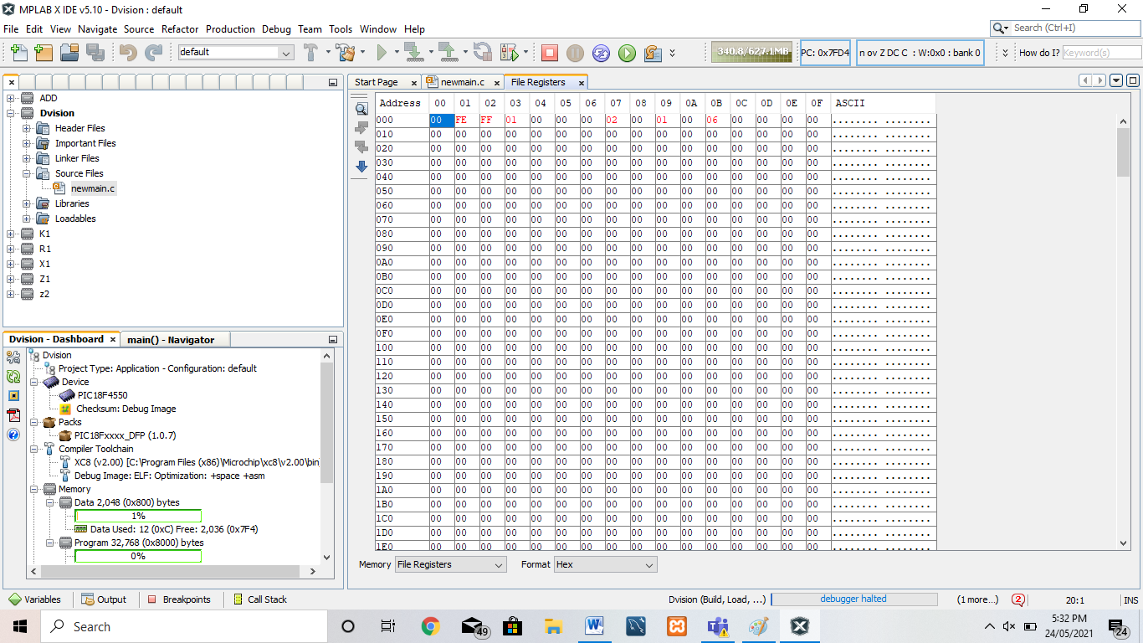

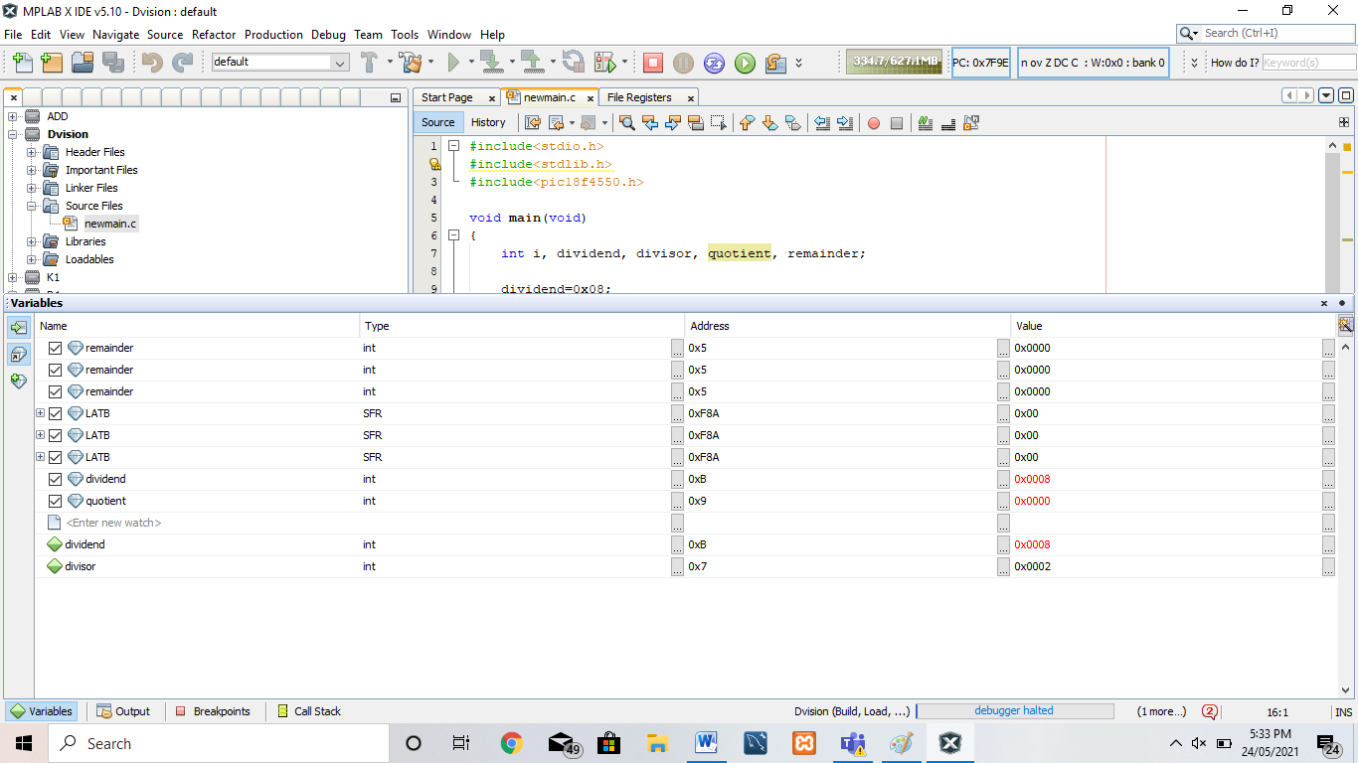

**Conclusion:** Thus, we have studied embedded C menu driven program for dividing 8 bit number by 8 bit number.